Implement the state design pattern for the following code:
class TrafficLight:
def __init__(self):
self.state = "Red" # Initial state is Red
def switch(self):
if self.state == "Red":
print("Red light -> Switching to green.")
self.state = "Green"
elif self.state == "Green":
print("Green light -> Switching to yellow.")
self.state = "Yellow"
elif self.state == "Yellow":
print("Yellow light -> Switching to red.")
self.state = "Red"
# Usage
traffic_light = TrafficLight()
# Simulate traffic light changes
traffic_light.switch() # Red -> Green
traffic_light.switch() # Green -> Yellow
traffic_light.switch() # Yellow -> Red
traffic_light.switch() # Red -> Green (cycle repeats)
Use the following UML to implement the pattern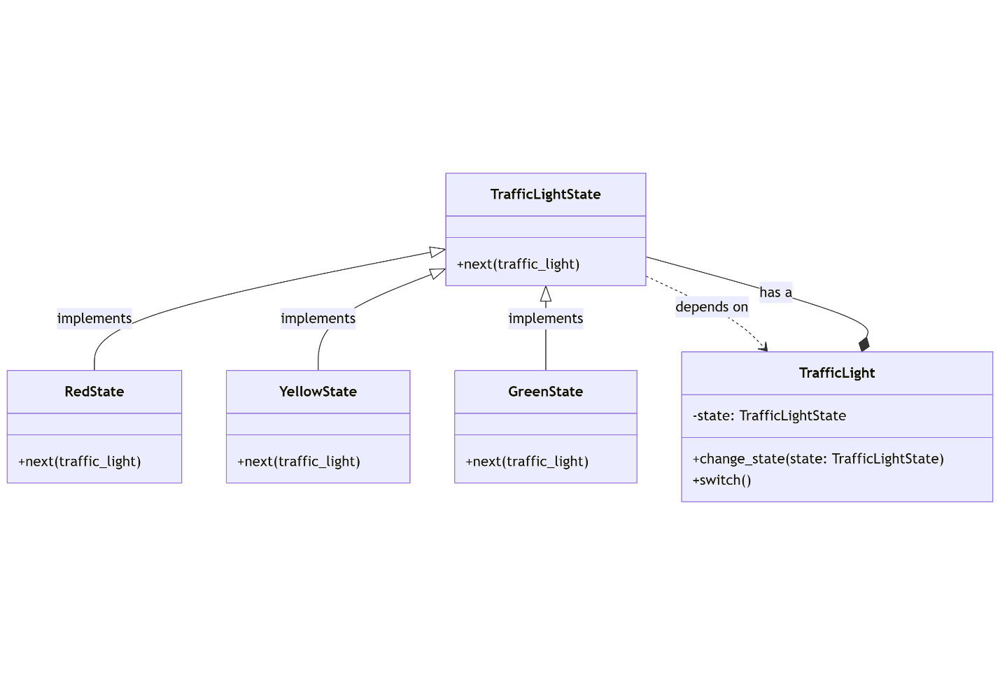:

from abc import ABC, abstractmethod
# State Interface
class TrafficLightState(ABC):
@abstractmethod
def next(self, traffic_light):
pass
# Concrete States
class RedState(TrafficLightState):
def next(self, traffic_light):
print("Red light -> Switching to green.")
traffic_light.change_state(GreenState())
class YellowState(TrafficLightState):
def next(self, traffic_light):
print("Yellow light -> Switching to red.")
traffic_light.change_state(RedState())
class GreenState(TrafficLightState):
def next(self, traffic_light):
print("Green light -> Switching to yellow.")
traffic_light.change_state(YellowState())
# Context
class TrafficLight:
def __init__(self):
self.state = RedState() # Initial state is Red
def change_state(self, state):
self.state = state
def switch(self):
self.state.next(self)
# Usage
traffic_light = TrafficLight()
# Simulate traffic light changes
traffic_light.switch() # Red -> Green
traffic_light.switch() # Green -> Yellow
traffic_light.switch() # Yellow -> Red
traffic_light.switch() # Red -> Green (cycle repeats)

